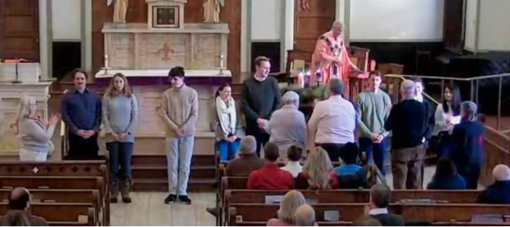

Please Pray for Our Elect

Caleb Collins Nadia Englund Aiden Guillory – Buckle Stella Haberman
Eva Lucus Jack Lucas Kyle Magann Christine Phan Merit Stewart Anwen Renae Winter

The OCIA Elect are a diverse group that have been called by Jesus Christ and desire to be in full communion with the Catholic Church. They are lawyers, government workers, college students, and more. Please keep them and their sponsors in your prayers.

A Prayer for Continued Conversion

Lord God, Creator of all things and source of all grace, we praise you for bringing these brothers and sisters to this point in their journey of faith. We ask you to send your Holy Spirit upon them, that they may continue to grow in you love and truth. Give them courage as they seek you, strengthening their resolve to follow you more closely every day.
Deepen their conversion to your Gospel, that their hearts may become more like you Son, Jesus Christ.
Support them through our community, that we may walk with them, supporting their faith journey with our love and prayers.
May they, who have begun this journey towards you, continue to find joy in your presence and, through the sacraments of you Church, become a light to the world. We ask this through Christ our Lord, Amen.
Please consider all or any of the following prayers for the Elect and for us all.
- We pray that together we may grow this lent in our love for God and neighbor, let us pray.
- That the Elect may be freed from selfishness and learn to put others first, let us pray
- That their sponsors may be living examples of the Gospel to inspire these Elect, let us pray.
- That their teachers may always convey to them the beauty of God’s word, let us pray.
- That these Elect may share with others the joy they have found in their friendship with Jesus, let us pray.
- That, trusting in the truth of Christ, they may find freedom of mind and heart and preserve it always, let us pray.
- That, freed by the power of the Spirit, they may put all fear behind them and press forward with confidence, let us pray
- That we who are faced with the values of the world may remain faithful to the spirit of the Gospel, let us pray.
- That the whole world, which the Father so loves, may attain in the Church complete spiritual freedom, let us pray.
- That God may lead them to Christ, the light of the world, let us pray.
- That all of us, by the example of our lives, may become Christ the light of the world, let us pray.
- That every inhabitant of the earth may acknowledge the true God, the Creator of all things, who bestows upon us the gift of Spirit and life, let us pray.



